DATE: [Month year]
FOR: [Project/client]

SWAT+ model protocol for [case]

DATE: [Day Month Year ]
AUTHORS: [First and last names]
CITE AS: [Last names, initials, Year. SWAT+ model protocol for case, xx p.]

Table of Contents
Introduction [note: update example below] 3
Code versions used [note: update example table below] 4
Weather input data used [note: update example table below] 5
GIS input data used [note: update example table below] 6
Stream discharge data used for calibration [note: update example below] 6
Model setup [note: update example below] 7
Delineation 7
HRU creation 8
Evaporation method 9
Water abstractions 9
Inputs of external groundwater from areas outside topographical watershed 9
Calibration and validation [note: update example below] 9
Summary [note: update example below] 12
References 13

Introduction [note: update example below]
The purpose of this model set up is to test the ability of the latest SWAT+ model, in terms of how well this can reproduce discharge in the Vejle and Grejs rivers in Denmark. This is an area in Denmark that is prone to flooding, and emphasis is therefore particular on peak flow events, and to assess whether the model could be suitable for operational forecasting.

Code versions used [note: update example table below]
Code | Version number | Availability
QGIS | 3.16.15 | QGIS used as a basis for running the QSWAT+ plugin. In this project, the latest stable release was used, which is the version that QSWAT+ aims to be compatible with. This can be downloaded from: https://qgis.org/downloads/QGIS-OSGeo4W-3.16.15-1.msi
SWAT+  (core model) | 60.5.4 | The SWAT+ fortran code is version controlled through bitbucket. Official code releases are available here: https://bitbucket.org/blacklandgrasslandmodels/modular_swatplus/src/master/
QSWAT+  (interface) | 2.1.8 | Code and official installer releases (including v2.1.8) are available here: https://bitbucket.org/ChrisWGeorge/qswatplus3/downloads/QSWATPlus3_9install2.1.8.exe
SWAT+ Editor (interface) | 2.0.4 | Code and official installer releases (including v2.0.4.) are available here: https://bitbucket.org/swatplus/swatplus.editor/downloads/  Direct link: https://bitbucket.org/swatplus/swatplus.editor/downloads/swatplus.editor-installer-2.0.4.exe
SWAT+ Toolbox  (calibration tool) | 0.7.6 | Sensitivity and calibration tool for SWAT+. Installers for the public releases is available here:  https://swat.tamu.edu/software/plus/  Source code for the SWAT+ Toolbox is available through github: https://github.com/OpenWaterNetwork/SWATPlus-Toolbox

Weather input data used [note: update example table below]
Data | Temporal resolution | Spatial resolution | Availability
Precipitation (ERA5) | Hourly  (used either as raw hourly inputs, or resampled to daily values in case of daily simulations) | 31km grid | ERA5 reanalysis data downloaded through the Climate Data Store (CDS) Application Program Interface (API). Raw data is in hourly resolution, which can be used directly, or resampled to daily data as input to the SWAT+ model. Info on: https://cds.climate.copernicus.eu/api-how-to
Min. and max air temperature | Hourly  (resampled to daily) | 31km grid | ERA5 reanalysis data downloaded through the Climate Data Store (CDS) Application Program Interface (API). Raw data is in hourly resolution, which was resampled to daily data as input to the SWAT+ model. Info on: https://cds.climate.copernicus.eu/api-how-to
Relative humidity | Hourly  (resampled to daily) | 31km grid | ERA5 reanalysis data downloaded through the Climate Data Store (CDS) Application Program Interface (API). Raw data is in hourly resolution, which was resampled to daily data as input to the SWAT+ model. Info on: https://cds.climate.copernicus.eu/api-how-to
Wind speed | Hourly  (resampled to daily) | 31km grid | ERA5 reanalysis data downloaded through the Climate Data Store (CDS) Application Program Interface (API). Raw data is in hourly resolution, which was resampled to daily data as input to the SWAT+ model. Info on: https://cds.climate.copernicus.eu/api-how-to
Radiation | Hourly  (resampled to daily) | 31km grid | ERA5 reanalysis data downloaded through the Climate Data Store (CDS) Application Program Interface (API). Raw data is in hourly resolution, which was resampled to daily data as input to the SWAT+ model. Info on: https://cds.climate.copernicus.eu/api-how-to

GIS input data used [note: update example table below]
Data | Map | Resolution | Availability
DEM | SRTM | 30m raster | Official 30m raster map hosted by the USGS. Data downloaded from the Earth Explorer system (https://earthexplorer.usgs.gov/). A guide is available on https://www.wateritech.com/training. Data may be cited with doi as https://doi.org/10.5066/F7K072R7.
Landuse | Corine | 100m raster | The CORINE Land Cover (CLC) inventory from 2018. Raster and SWAT+ lookup table downloaded from https://wateritech.com/datalab. Dataset may be cited as EEA (2018).
Soil | HWSD | 1km raster | Soil texture map from the Harmonized World Soil Database (HWSD) compiled by FAO and IIASA, 2012. Raster, SWAT+ database and lookup table downloaded from https://wateritech.com/datalab.
Lakes  (optional) | Lake-theme | Vector (shapefile)
Rivers  (optional) | River-theme | Vector (shapefile)

Stream discharge data used for calibration [note: update example below]
Data | Temporal resolution | Spatial resolution | Availability
Stream discharge | daily | Provided from individual gauge stations | Observed daily discharge data was downloaded from https://hip.dataforsyningen.dk/ for the Grejs river “Planteskolen” station, and the Vejle river “Haraldskær” station, respectively.

Model setup [note: update example below]

Delineation
Channel threshold: 1 km² (minimum size of sub-watershed, and thereby a landscape unit (LSU), where a small channel that drains to a main stream is created)
Stream threshold: 10 km² (minimum size of sub-watershed, where a main stream is created)
Upslope/Floodplain LSUs: This is optional. This will divide each LandScape Unit (LSU) into an Upslope and a Floodplain LSU, and create individual aquifers per LSU (representing the Upslope and the Floodplain areas, respectively). This may render a more realistic flow path for groundwater to the main stream in each subbasin, but also result in a higher computational burden and parameter complexity. When delineating Upslope and Floodplain LSUs, we used the “DEM inversion” approach with default settings as indicated here (note this process can take several minutes):
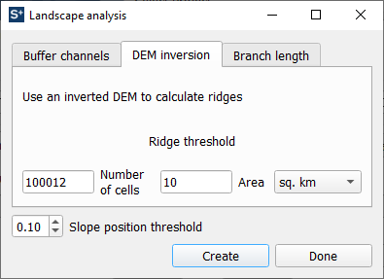
Lakes: This is optional. In the present project, we included a shapefile with Lake Engelsholm and Lake Fårup. The delineation will then tailor LSU boundaries to the shoreline of the lakes.
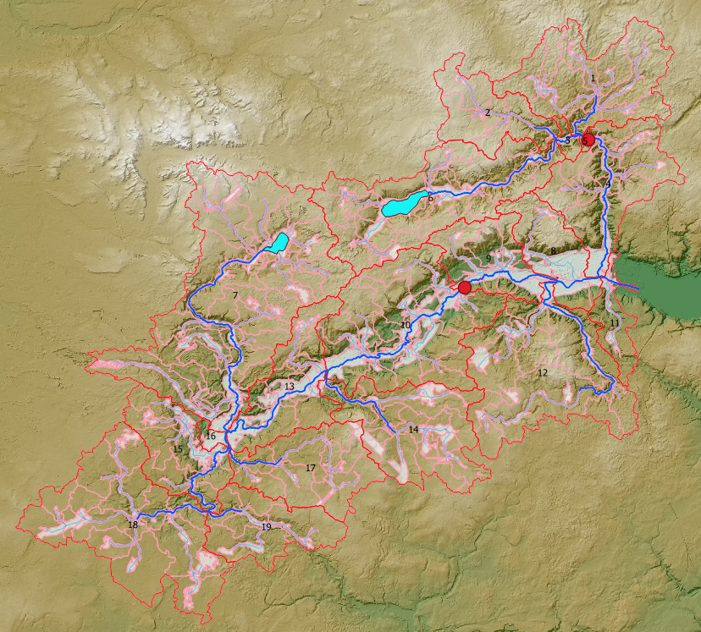
Figur 1. Watershed, subbasins and streams delineated by SWAT+ with floodplain delineation (areas delineated as floodplains are indicated by light shaded areas). The stream gauge stations at Grejs river (Planteskolen, at outlet of channel # 19) and Vejle river (Haraldskær, at outlet of channel # 57) are indicated by red points.

HRU creation
Land use Corine raster by EEA 2018 and lookup table by WaterITech.
Soil Soil texture map from HWSD. Soil database and lookup table by WaterITech.
Slope classes 3 classes (0-2%, 2-8% and > 8%).
HRU filtering 10% threshold for landuse, soil type and slope class.

Final configuration:
# Total watershed area: 338 km²
# Subbasins: 19
# LSUs: 390 (including both upslope and floodplain LSUs)
# HRUs 4,642 (in total 24,429 HRUs were identified before applying 10% filter)

Evaporation method
SWAT+ includes the choice of different evaporation methods including Hargreaves, Penmann/Montieth, Priestly/Taylor or user defined time series. A study by Samadi (2017) suggested that Priestly/Taylor may provide best performance when simulating extreme events. Trolle and Nielsen (2020) found that Penmann/Montieth generally resulted in a better performance for the Vejle pilot area. Therefore, this method was chosen in the present project.

Water abstractions
None included.

Inputs of external groundwater from areas outside topographical watershed
In SWAT+, users can add additional water sources in various ways. This can be done using the “recall” functionality, which allows users to add a constant or a time series input of additional water. For both the Grejs and Vejle river systems, it is well known that groundwater from outside the topographical watershed contributes to the discharge in both streams. This was experimented with and documented in the previous study by Trolle and Nielsen (2020). In summary, the discharge at Planteskolen and Haraldskær is minimum 30-50 % higher than nearby stations, which can be attributed to groundwater contribution from outside the topographical catchment. To account for the external groundwater input, we applied a constant input of water (by manipulating the file: exco_om.exc). We used 75,000 m³/day at recall point 28 upstream (north-west) of the Grejs river gauge station, and 250,000 m³/day at recall point 396 upstream (south-west) of the Vejle river gauge station, which corresponds to roughly 30-40% of the observed discharge during the calibration period.

Calibration and validation [note: update example below]
Calibration was first done by a semi-automatic (inverse) calibration routine available through the SWAT+ Toolbox (developed by Celray James Chawanda, of VUB, Belgium). The Dynamically Dimension Search (DDS) approach, which is built into SWAT+ Toolbox, was utilized for parameter optimization. DDS has demonstrated good performance in terms of computational speed and the ability to break through local solutions when calibrating complex hydrological models (Yen et al. 2015). Calibration was done as a multiobjective for the Grejs river station and Vejle river gauge station. In practice, several iteration were run with approx. 100 model simulations, after which the sample parameter ranges were gradually narrowed by inspected dotty plot (relation between parameter values and the objective function).
The calibration was performed by optimization of the Nash-Sutcliffe Efficiency (NSE), which, like the coefficient of determination (R²), is a correlative objective function. Percent bias, which is a residual objective function, was also evaluated. Classification of the performance was done by comparing performance against the criteria reviewed by Moriasi et al. (2015). The followed time periods were used:
- Model warmup: 1. August 2011 - 31. July 2014 (three hydrological years)
- Calibration: 1. August 2014 - 31. July 2016 (two hydrological years)
- Validation: 1. August 2016 - 31. July 2018 (two hydrological years)

Table 1 Parameters chosen for calibration.
Parameter | Change type | Value Planteskolen | Value Haraldskær | Average value
cn2 | Percent | -29.563 | -26.459 | -28.011
alpha | Replace | 0.366 | 0.431 | 0.3985
k | Percent | 391.65 | 220.216 | 305.933
esco | Replace | 0.807 | 0.761 | 0.784
epco | Replace | 0.821 | 0.924 | 0.8725
awc¹ | Percent | 18.01096 | -18.12302 | -0.05603
[1] May not be sensitive in SWAT+ code v. 60.5.
Table 2 Performance evaluation criteria for recommended statistical performance measures for watershed models by Moriasi et al. (2015).
Objective function | Output response | Temporal scale^{[1]} | Performance Evaluation Criteria
Objective function | Output response | Temporal scale^{[1]} | Very Good | Good | Satisfactory | Not Satisfactory
R² | Flow^{[2]} | D-M-A | R² > 0.85 | 0.75 < R² ≤ 0.85 | 0.60 < R² ≤ 0.75 | R² ≤ 0.60
R² | Sediment/P | M | R² > 0.80 | 0.65 < R² ≤ 0.80 | 0.40 < R² ≤ 0.65 | R² ≤ 0.40
R² | N | M | R² > 0.70 | 0.60 < R² ≤ 0.70 | 0.30 < R² ≤ 0.60 | R² ≤ 0.30
NSE | Flow | D-M-A | NSE > 0.80 | 0.70 < NSE ≤ 0.80 | 0.50 < NSE ≤ 0.70 | NSE ≤ 0.50
NSE | Sediment | M | NSE > 0.80 | 0.70 < NSE ≤ 0.80 | 0.45 < NSE ≤ 0.70 | NSE ≤ 0.45
NSE | N/P | M | NSE > 0.65 | 0.50 < NSE ≤ 0.65 | 0.35 < NSE ≤ 0.50 | NSE ≤ 0.35
PBIAS (%) | Flow | D-M-A | PBIAS ≤ ±5 | ±5 ≤ PBIAS < ±10 | ±10 ≤ PBIAS < ±15 | PBIAS ≥ ±15
PBIAS (%) | Sediment | D-M-A | PBIAS ≤ ±10 | ±10 ≤ PBIAS < ±15 | ±15 ≤ PBIAS < ±20 | PBIAS ≥ ±20
PBIAS (%) | N/P | D-M-A | PBIAS ≤ ±15 | ±15 ≤ PBIAS < ±20 | ±20 ≤ PBIAS < ±20 | PBIAS ≥ ±30
[1] D, M and A denote daily, monthly, and annual temporal scales, respectively.
[2] Includes stream flow, surface runoff, base flow, and tile flow, as appropriate, for watershed models.

Table 3 Performance of SWAT+ model for Grejs river and Vejle river.
Objective function | Grejs river  calibration^{[1]} | Grejs river  validation ^{[1]} | Vejle river  calibration^{[1]} | Vejle river  validation ^{[1]}
R² | 0.79 (good) (DK: 0.79) | 0.81 (good) (DK: 0.76) | 0.8 (good) (DK: 0.77) | 0.85 (very good) (DK: 0.84)
NSE | 0.68 (satisfactory) (DK: 0.01) | 0.75 (good) (DK: -0.83) | 0.57 (satisfactory) (DK: 0.74) | 0.52 (satisfactory) (DK: 0.83)
PBIAS (%) | -0.18 (very good) (DK: 55.44) | -7.39 (good) (DK: 62.09) | 1.18 (very good) (DK: 7.2) | -0.65 (very good) (DK: 1.13)
[1] Classification according to Moriasi et al. (2015) noted in parenthesis.
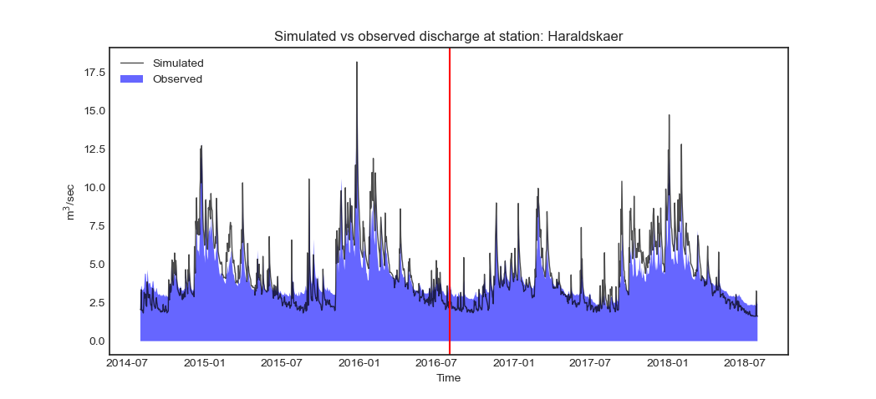
Figur 2. Observed and simulated discharge for Vejle river, at ”Haraldskær” gauge station (2014-2018) for the calibrated model. Calibration and validation periods are seperated by red vertical line (plot produced using Python script by WaterITech).

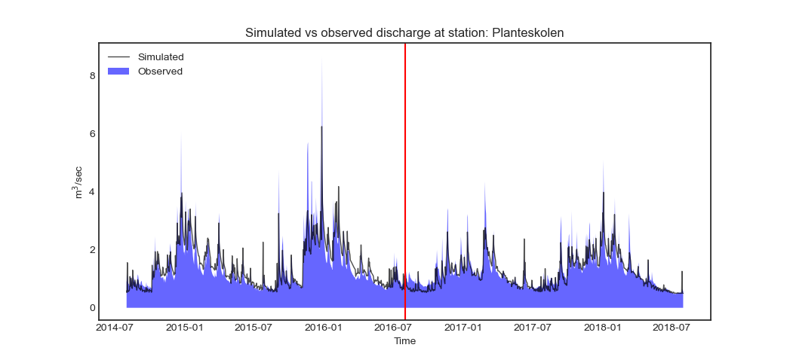
Figur 3. Observed and simulated discharge for Grejs river, at ”Planteskolen” gauge station (2014-2018) for the calibrated model. Calibration and validation periods are seperated by red vertical line (plot produced using Python script by WaterITech)..

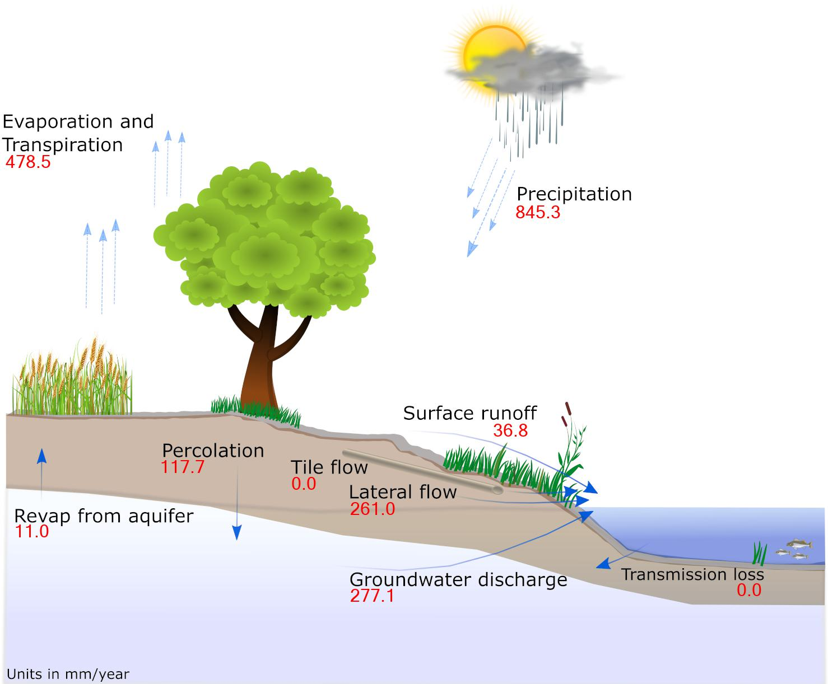
Figur 4. Key watershed-wide hydrology components simulated for period 2014-2018 (based on the calibrated model). Groundwater discharge include 192 mm/year from sources outside topographical watershed (plot produced using Python script by WaterITech).

Summary [note: update example below]
A SWAT+ model was set up from scratch for the Grejs and Vejle rivers systems. Data used in the Vejle Pilot project are all available at national level, and therefore the SWAT+ approach used in the project can be applied all across Denmark. The SWAT+ model was calibrated on a daily time step, and produced generally very good results for river discharge in both rivers. Peak flows, in particular, were much better reproduced by the SWAT+ model compared to the existing DK model. While the SWAT+ code for sub-daily simulations still required some minor developments during the time of the Vejle Pilot study, it is expected that this will developed and soon released by the core developers at USDA in the US, which could potentially further improve the simulation of peak flows.

References

EEA. 2018. CORINE Land Cover (CLC), © European Union, Copernicus Land Monitoring Service 2018, European Environment Agency (EEA), https://land.copernicus.eu/pan-european/corine-land-cover.
Moriasi, D.N., Gitau, M.W, Pai, N., and Daggupati, P. 2015. Hydrologic and Water Quality Models: Performance Measures and Evaluation Criteria. Transactions of the ASABE. 58(6): 1763-1785. doi: 10.13031/trans.58.10715.
Samadi, S.Z. 2017. Assessing the sensitivity of SWAT physical parameters to potential evapotranspiration estimation methods over a coastal plain watershed in the southeastern United States. Hydrology Research, 48.2: 395-415.
Trolle, D., Nielsen, A. 2020. SWAT+ model protocol for Vejle pilot. Report by WaterITech prepared for DMI, December 2020, 12p.
Yen, H., Jeong, J., Tseng, W.H., Kim, M.K., Records, R.M., Arabi, M. 2015. Computational Procedure for Evaluating Sampling Techniques on Watershed Model Calibration. J. Hydrol. Eng. 2015, 20, 04014080.

